Waterproofing a canister

Creating a waterproof canister is not too difficult. All you need to do is glue or weld some end caps onto ABS, PVC or metal pipe and you have a waterproof container. Making a waterproof container and then drilling holes into it for wires, creates a number of complications. Water pressure, even at the depths found in MATE Competition pools, will push water through pipe threads, openings, holes or weak spots. This can leave your canister flooded and your electronics inoperative.

So what can you do to keep the electronics inside the canister dry and operable?

Use a professional penetrator. If you are spending thousands of dollars, tens of thousands of dollars, to construct a vehicle, spending a few hundred on a professional penetrator may be cost effective.
What is the value of your watertight electronics?

There are many companies that sell professional waterproof electric connectors.

Subconn: www.subconn.com/
Sea Con: http://seaconworldwide.com/products/penetrators/
Teledyne Impulse: www.teledyneoilandgas.com
SOURIAU: www.souriau.com/underwater/accueil.html
Underwatersystems.com: www.underwatersystems.com

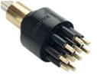
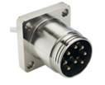

SubConn connectors

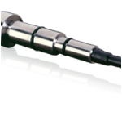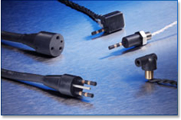
Sea Con connector Teledyne Impulse connectors

If a professional penetrator, underwater connector is not in your budget, how can you waterproof the holes you drilled into your watertight canister?

One good site is:
www.homebuiltrovs.com/howtosealingwireexits.html

This method is similar to one the MATE Center has been using for a couple of years, but we have one important modification.

So what is the problem with just using epoxy to seal your hole?

Basic Epoxy Seal

Drill a hole through your canister.

Insert your wire through the hole.

Use epoxy to seal the hole.
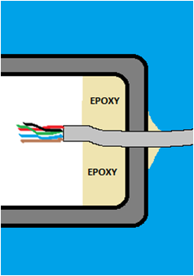

Water still has an easy path into your watertight canister.
If the sheathing on your tether gets a break or hole in it, water will penetrate into the sheath.

Water can then bypass your epoxy seal inside the sheath.

Water will even pass through stranded wire or between the insulation on the wire and the wire itself.

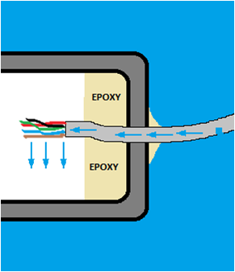

Water pressure will get in through any break in the wire that it can.

To avoid water penetrating through the sheath or through the wire, strip each individual wire. Epoxy will surround the wire and
Stagger the wire stripping so that no areas of bare wires are can touch other areas of bare wire. This will avoid short to ground, short to voltage or other electrical problems.


Water cannot penetrate through the seals.

Even if water is moving down between the wire and insulator, it will not get past the stripped and sealed portion.

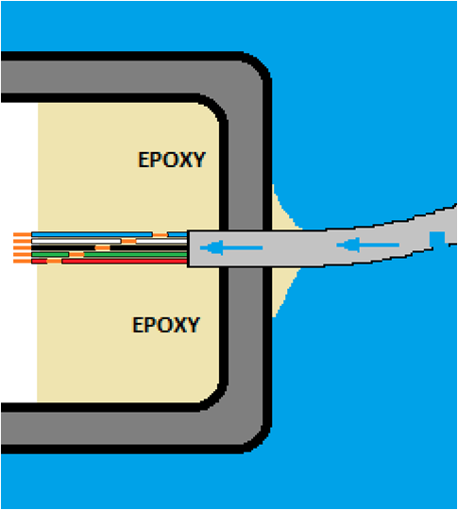

CLOSE UP VIEW


Water penetration cannot pass the epoxy – wire seal.

